**Day 6**

**Task 1:**

**Regex symbols with description:**  
  
Dot (.) - It is called a wild card character, it matches any one character other than the new line.

^ - It matches the start of the string.

$ - It matches the end of the string.

* - It matches up to zero or more occurrences i.e. any number of times of the character of the string.

\ - It is used for escape following character.

() - It is used to match or search for a set of regular expressions.

? - It matches exactly one character in the string or stream

**Task 2 :**

**Features of Linux:**

1. Open source
2. Secured
3. Flexible - widely used in servers.
4. Performance
5. Adaptability
6. Supports many scripting languages and automation of tasks.

**Task 3:**

**WHAT IS Kernel and can you explain its functions?**

A kernel is the core of an operating system (OS), acting as a bridge between the OS and the computer's hardware. It manages system resources like CPU, memory, and devices, ensuring they work together efficiently. In essence, the kernel handles low-level tasks and allows applications to interact with the hardware without needing to know the details.

Features of kernel are:

1. Resource management.
2. Process management.
3. Memory Management.
4. File system management.
5. Input output management.
6. Device management.
7. Security.

**Task 4:**

**What is BASH and full form of BASH?**

Bash stands for Bourne Again SHell. It's a command-line interpreter and scripting language used on Linux, macOS, and other Unix-like operating systems. It's a powerful tool for interacting with the operating system and automating tasks.

**Task 5:**

**What is the difference between window and linux?**

| **S. No** | **Linux** | **Windows** |
| --- | --- | --- |
| 1. | Linux is an **open-source** operating system. | Windows is **not** an open-source operating system. |
| 2. | Linux is **free of cost**. | Windows is **paid** and requires a license. |
| 3. | **File names are case-sensitive**, meaning file.txt and File.txt are different. | **File names are case-insensitive**, meaning file.txt and File.txt are treated the same. |
| 4. | Uses a **monolithic kernel**. | Uses a **hybrid kernel**. |
| 5. | **More efficient and stable**, especially for servers and developers. | **Less efficient** due to resource-intensive processes. |
| 6. | Uses **forward slash (/)** for directory separation. | Uses **backslash (\)** for directory separation. |
| 7. | **More secure** with better user control and fewer vulnerabilities. | **Less secure** due to higher susceptibility to malware and viruses. |
| 8. | Preferred by **hackers and security experts** due to its open-source nature and control. | **Not widely used for hacking** as it lacks built-in security tools. |
| 9. | Has **3 types of user accounts**: (1) Regular, (2) Root, (3) Service Account. | Has **4 types of user accounts**: (1) Administrator, (2) Standard, (3) Child, (4) Guest. |
| 10. | **Root user** has all administrative privileges. | **Administrator user** has all administrative privileges. |
| 11. | In Linux, you **can have two files with the same name** but different cases (File.txt and file.txt). | In Windows, **you cannot have two files with the same name** in the same folder. |

**Task 6:**

**Define the basic components of Linux**

The main components of a Linux operating system include the kernel, shell, system libraries, system utilities, and hardware.

**Task 7:**

**Is it legal to edit Kernal?**

Yes, it is legal to edit the Linux kernel, as it is released under the GNU General Public License (GPL), which allows for modification and redistribution of the software. However, certain conditions apply if you intend to distribute your modified version.

**Task 8:**

**how many of you have gone through techadamy Linux plz raise ur hand**

16 pax done out of 29

Can you explain LILO

10.34 to 10.40 6 min

**Task 9:**

**What is shell? How many shells are there and what are they ? can you explain.**

A shell is a program that provides a user interface to an operating system (OS), allowing users to interact with the system. It acts as a command-line interpreter, taking user input, interpreting it, and executing corresponding actions. There are many different types of shells, each with unique features and purposes.

Types of shells:

1. Command line

2. GUI

**Task 10:**

**What is Swap space ?**

Swap space, also known as virtual memory, is a storage area on a computer's hard drive or SSD that acts as an extension of its physical RAM (Random Access Memory). It's used when the RAM is full, temporarily storing inactive data that is not immediately needed, preventing system crashes due to memory shortages.

**Task 11:**

**What is Mount ? how do you mount and unmount file system in Linux?**

Mounting is attaching the filesystem to the directory structure in unix and unix like operating system. Unmounting means safely detaching the filesystem from its mount point directory.

For Mount: use mount diskname/directory

For Unmount: use unmount /directory

**Task 12:**

**What is chmod command ? how to use it?**

The chmod command in linux is used to change the permissions of files and directories.

It allows to control who can read, write and execute the files.

chmod [who] [operator] [permission] [filename]

**Task 13:**

**Can you add a new user account? Create a new user in different ways and paste ss**

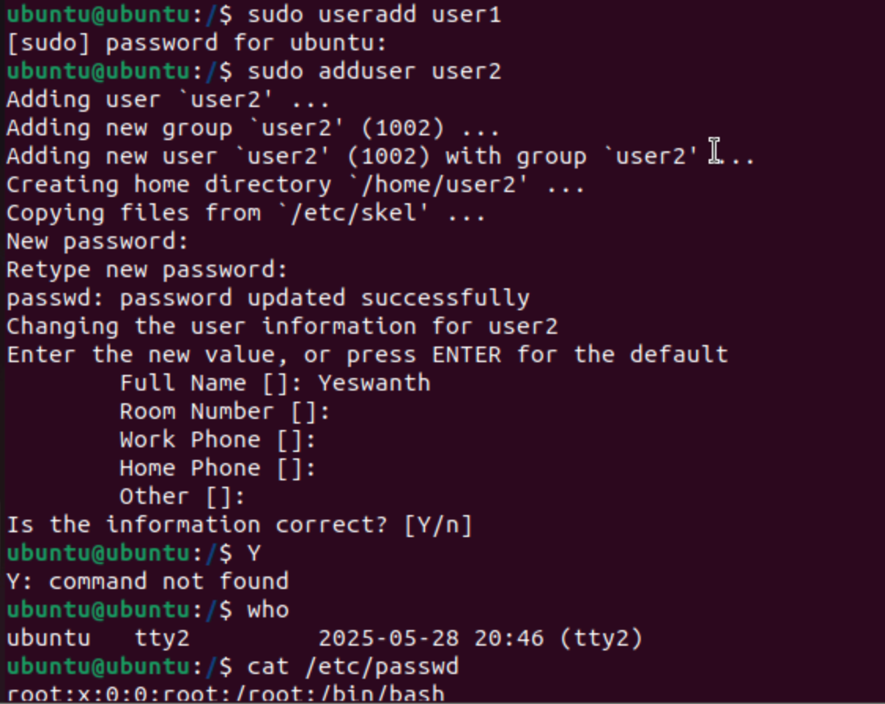

**Task 14:**

**Can you change the password of a user?**

**How do you do that? Plz share ss**

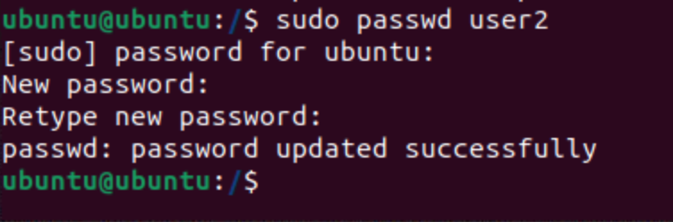

**Task 15:**

**What is diff between Process and Thread?**

Process:

1. A process is a program in execution.

2. Process takes more time to execute.

3. It takes more time for creation

4. Multiprogramming holds the concepts of multi-process.

5. A process is less efficient in terms of communication.

6. Process runs in its own memory.

Thread :

1. Thread is a segment of process.
2. Thread takes less time to execute.
3. Thread takes less time for creation.
4. Thread is more efficient in terms of communication.
5. We don't need multi programs in action for multiple threads because a single process consists of multiple threads.
6. Threads share memory.

**Task 16:**

**Linux Grep commands:**

**Note: Some Screenshots have 2 or more commands practiced some have only one.**

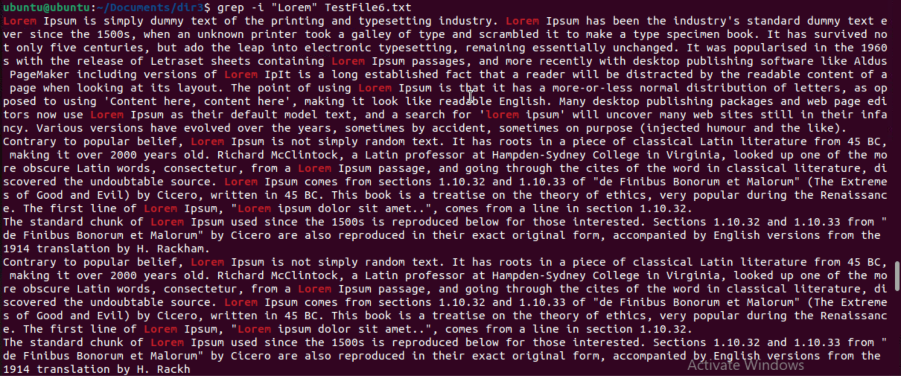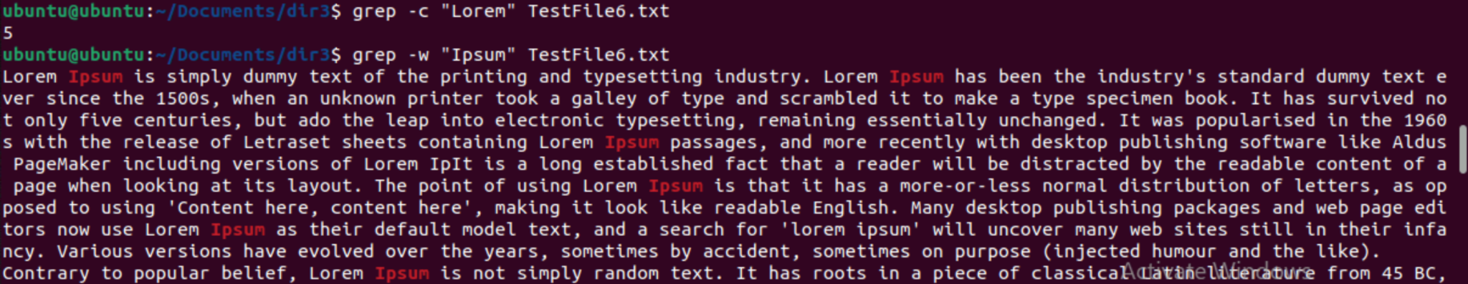

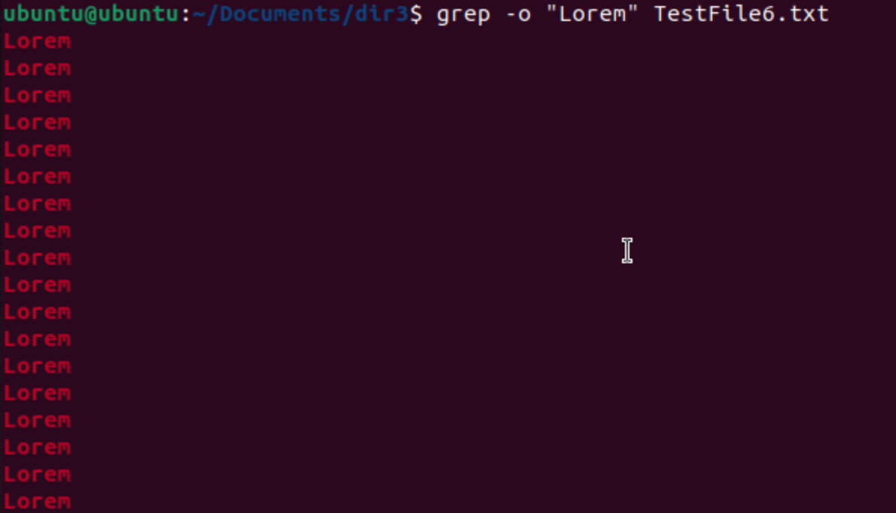

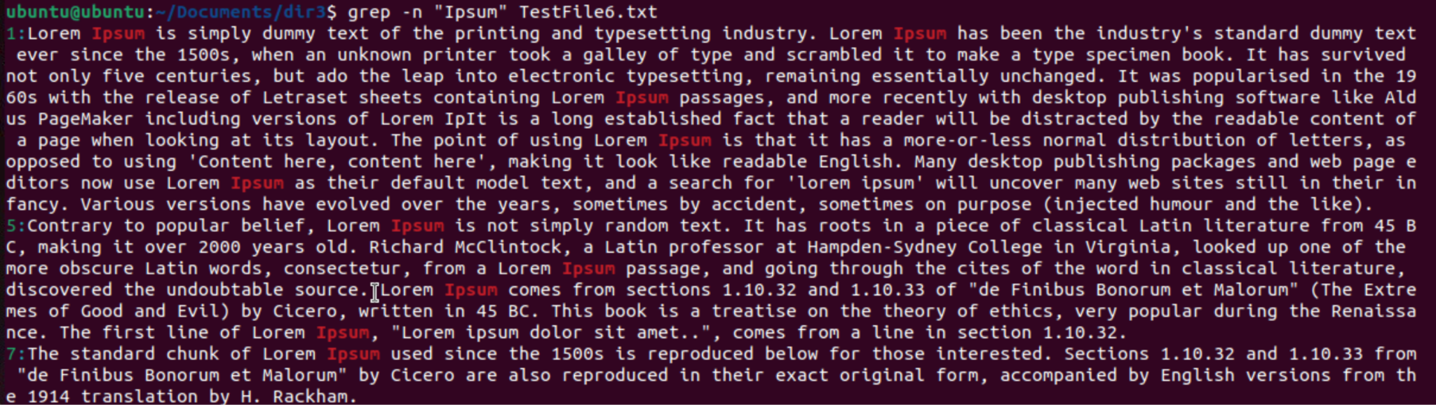

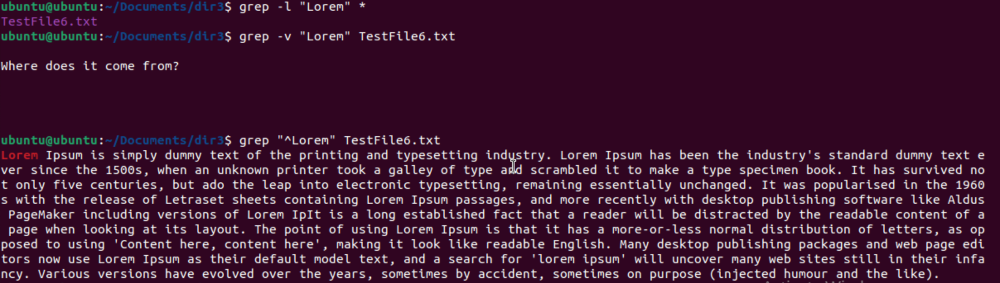

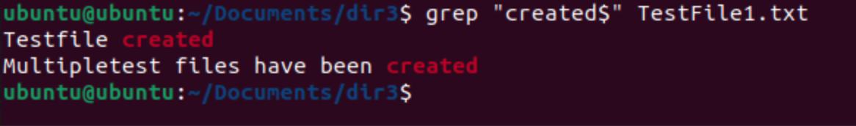

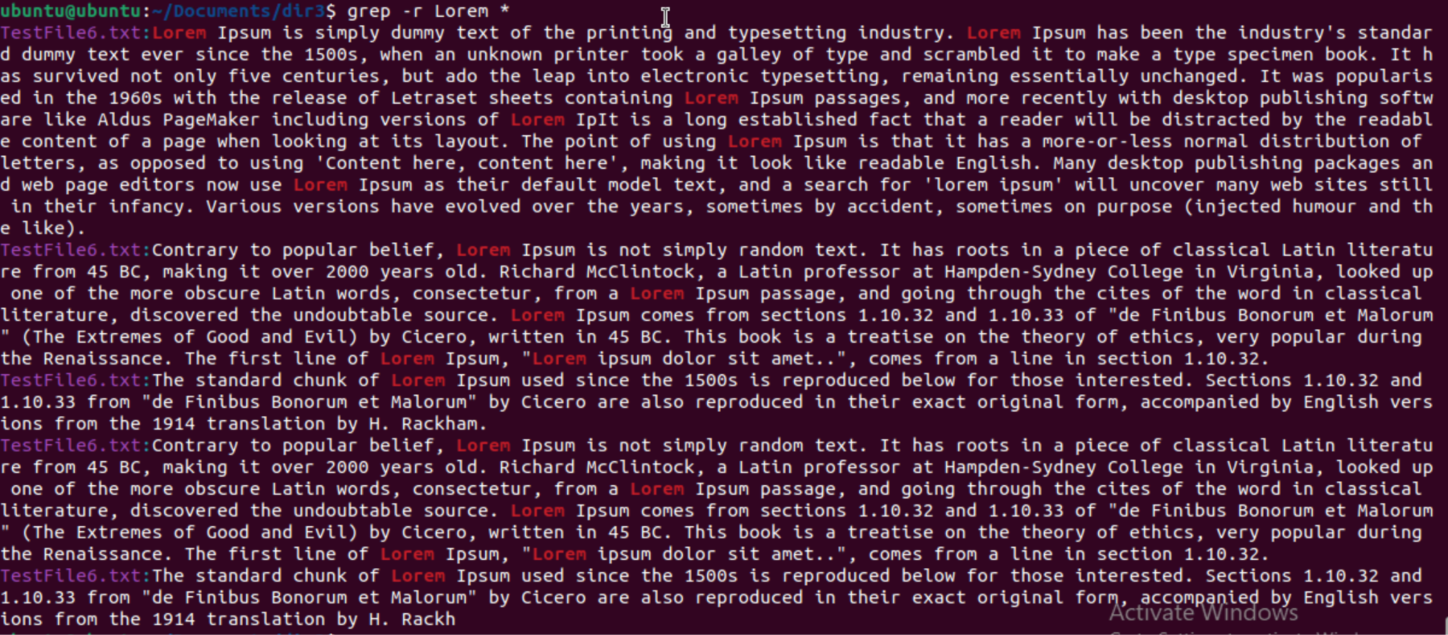

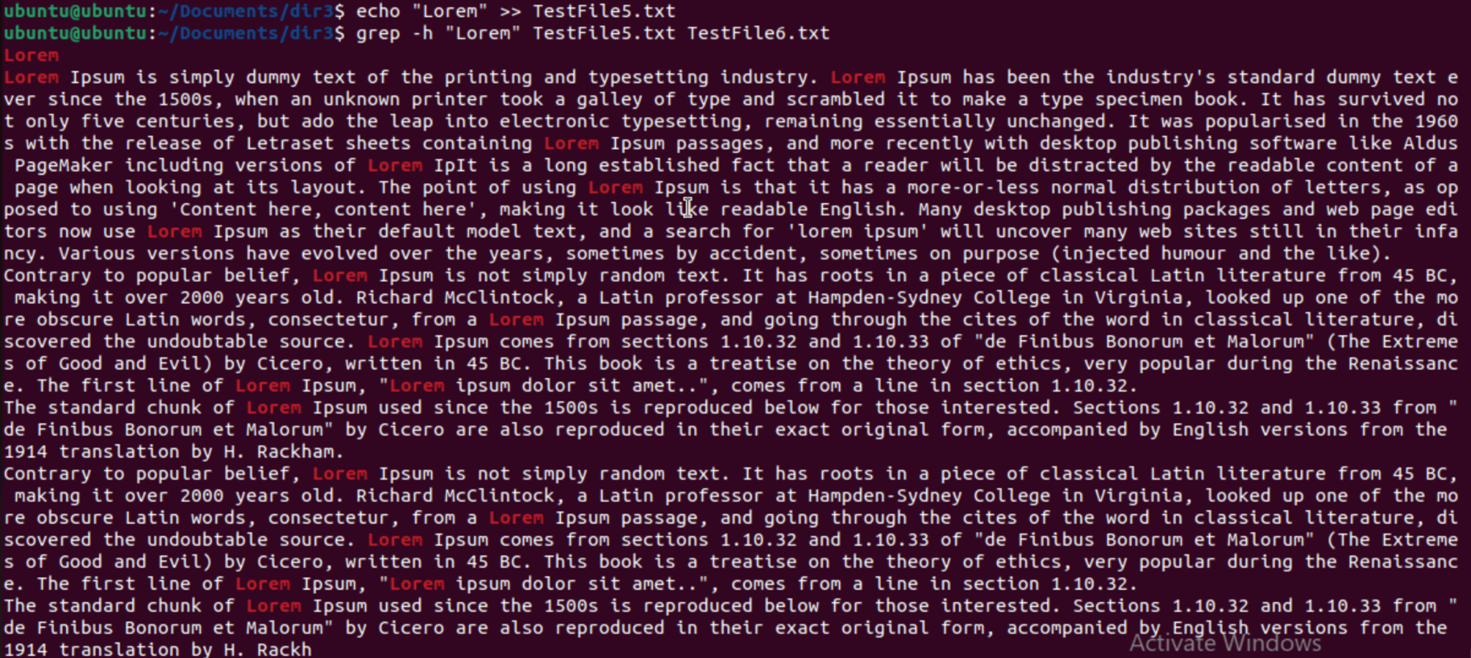

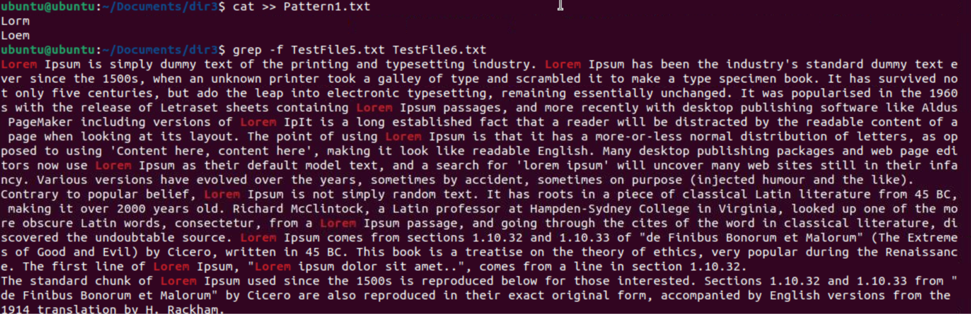

**Task 17:**

**AWK commands**

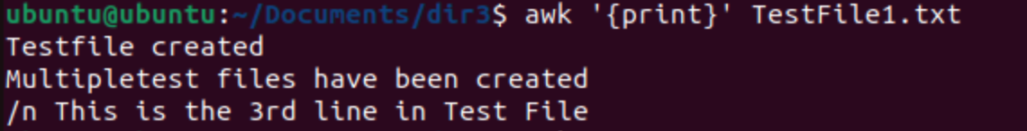

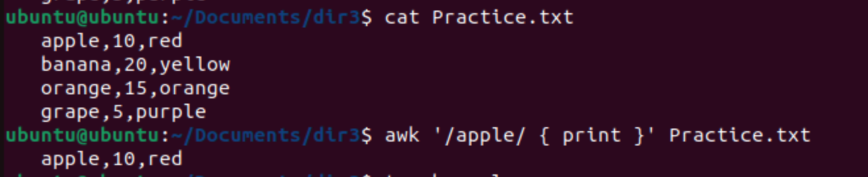

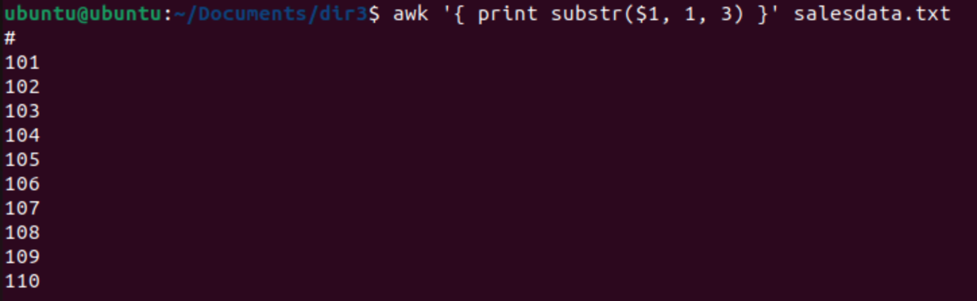

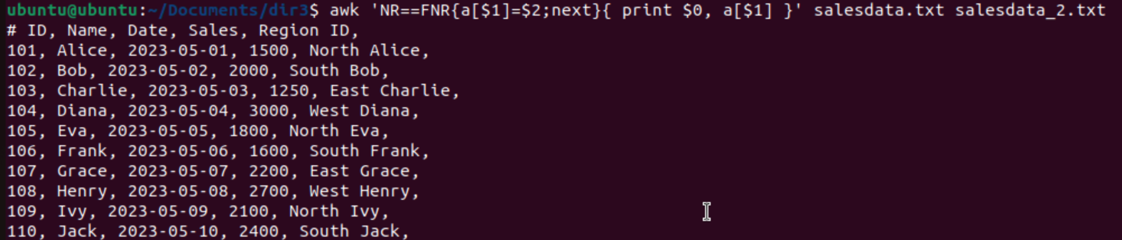

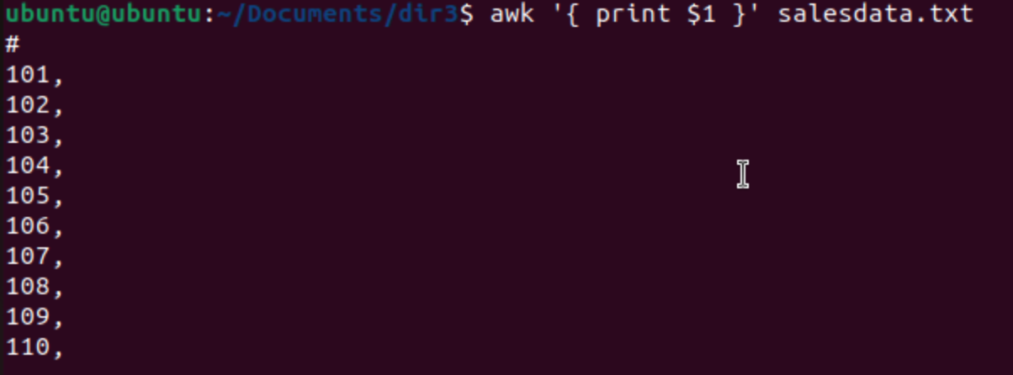



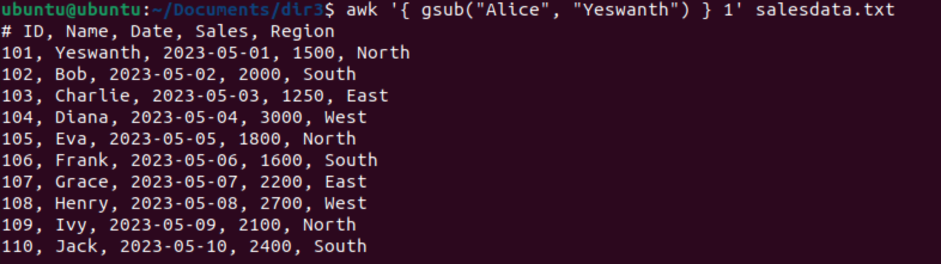

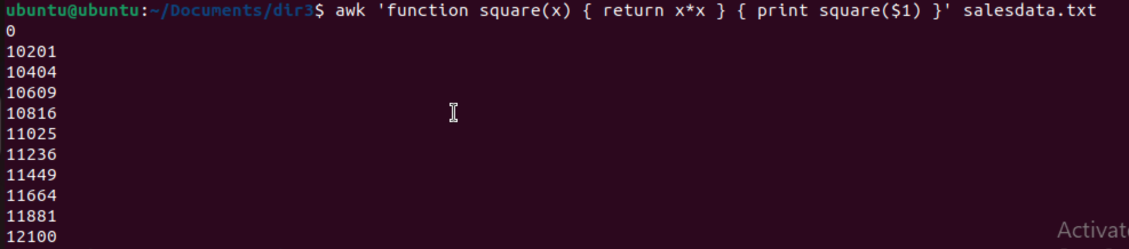

Task 18:

How to check file access permission in Linux?

Hint use:

Ls -l

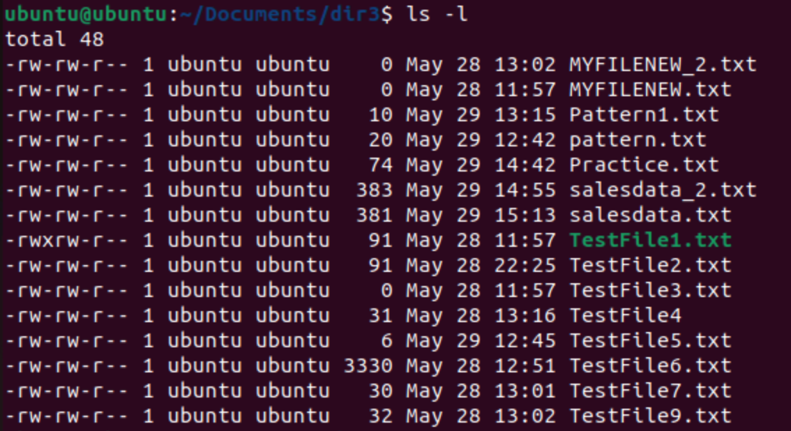

**Task 19:**

**What are the default permissions for a new file ?**

Owner → Read, write

Group → Read write

All and others → Read

**Task 20:**

**What is the command to change the permisssion to read only for the owner, group and all other users**

**HInt: chmod 444 filename**

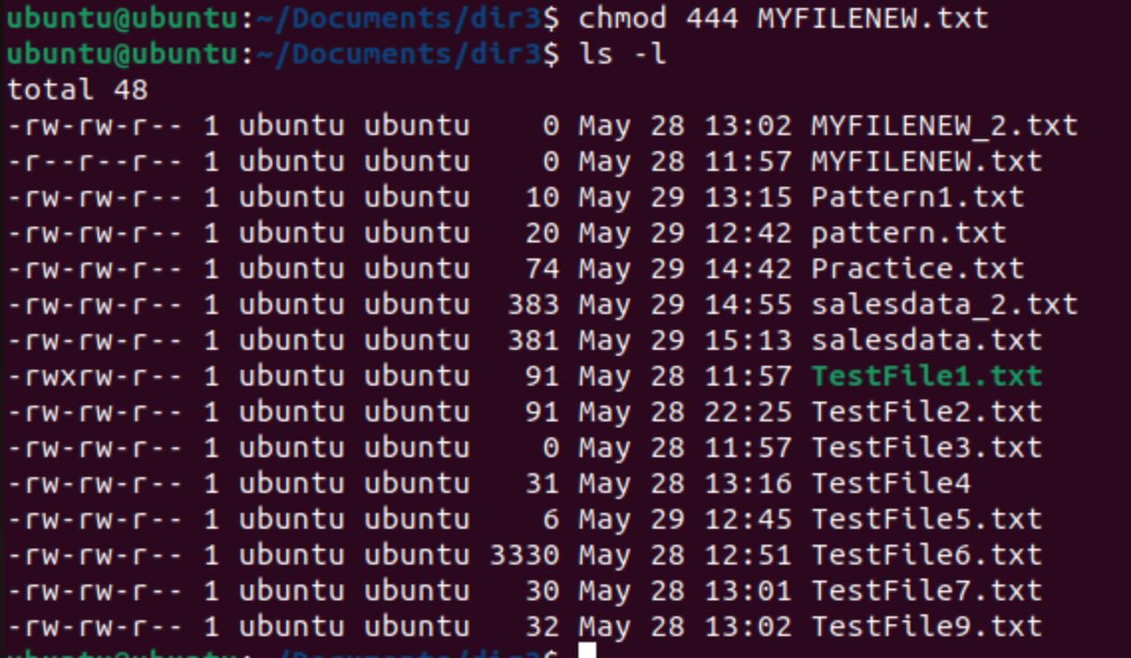

**Task 21:**

**Can you change the file permissions to match the following:**

* **owner: Read and Write**
* **group: Read**
* **other: no permissions (None)**

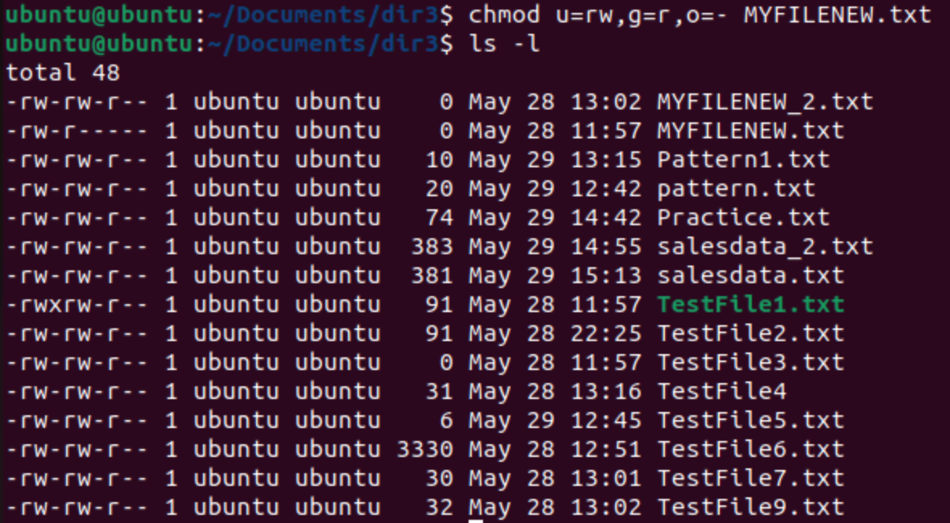

**Task 22:**

**What was the command for changing the file permissions to -rw-r-----?**

**Hint : use chmod 640 filename**

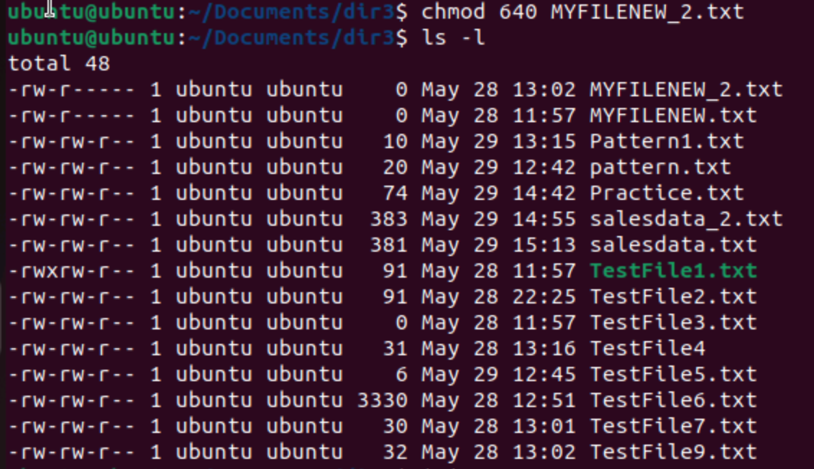

**Task 23:**

**Change chmod.exercises permissions to -rwxr-x--x**

**Change the file permissions to match the following:**

**owner: Read, Write and Execute**

**group: Read and Execute**

**other: Execute**

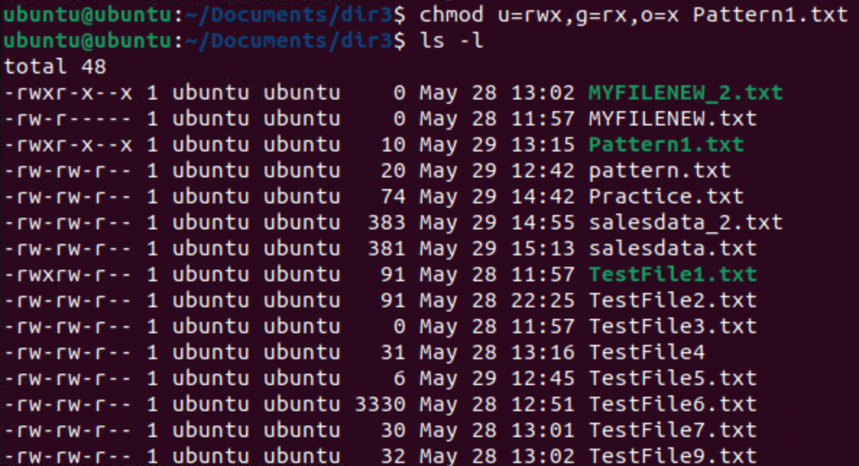

**Task 24:**

**What was the command for changing the file permissions to -rwxr-x--x**

**Hint : use chmod 751 filename**

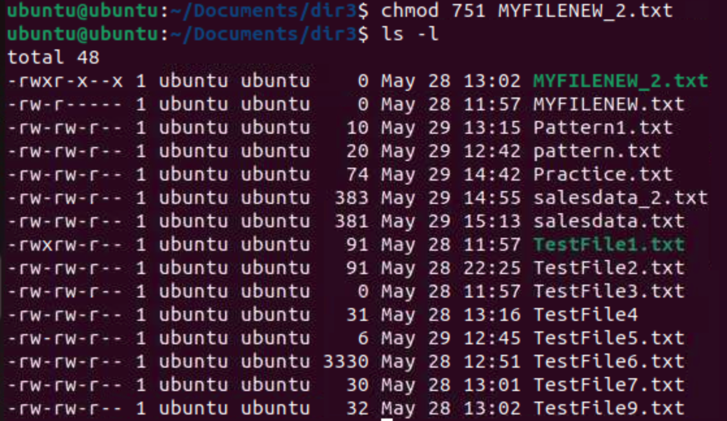

Task 25:

Guys what will this command do?

chown -c master file1.txt

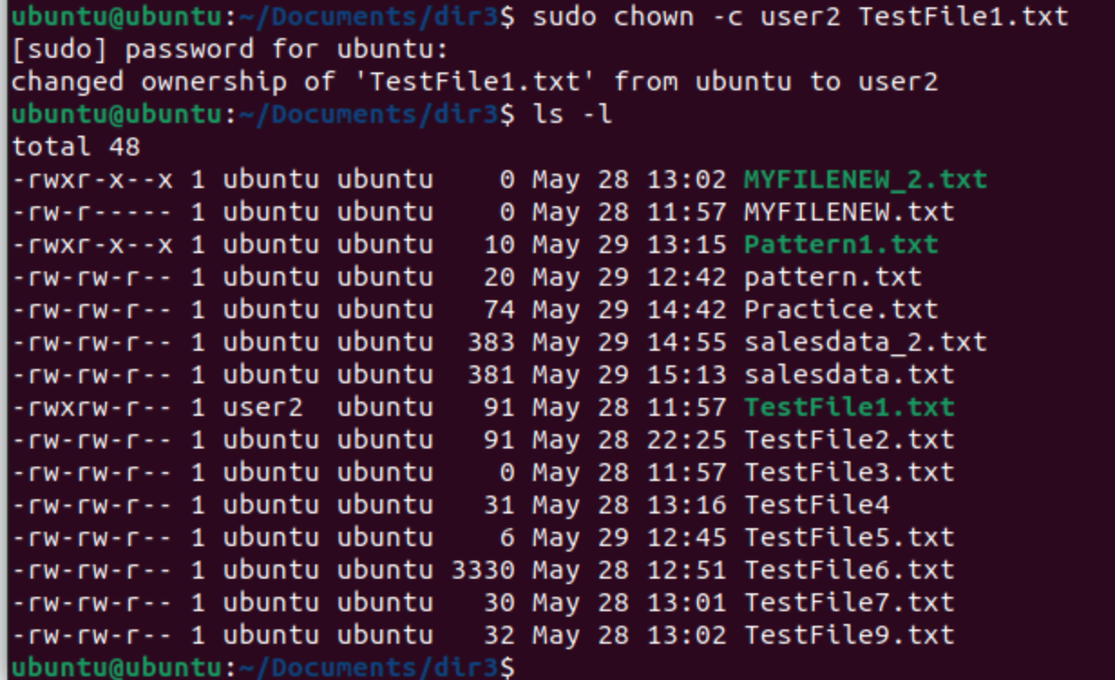

Processes 👍

Task 26:

Can you define what is a process

In Linux, a process represents a program that is currently running and executing code. Every time you execute a command, a new process is created. These processes are managed by the Linux kernel and have a unique identifier (PID) associated with them.

Task 27:

What is command to check foreground process and background process

ps -u $LOGNAME: This command displays processes owned by the current user, which is often a good way to narrow down the list of processes to those running on the current terminal session.

Jobs - to check all the background process.

Task 28:

Can you list all the running processes?

Hint use ps

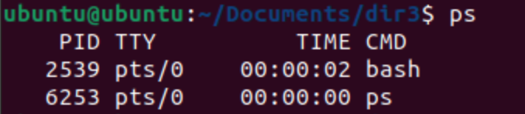

Task 29:

What will ps -f command do ? plz try n check .. ss required.

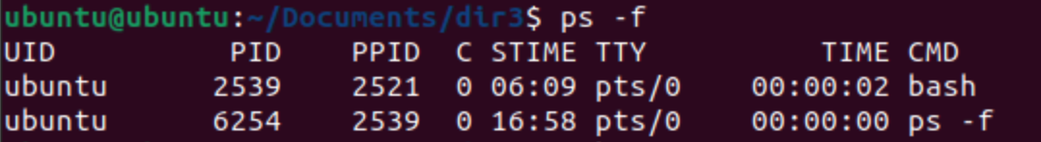

Lets play with shell variables

Task 30:

Can you createa a variable name with your name in it

Ex:

Name = “prasunamba”

Id = 10001

And check

Echo $Name

Chek the output

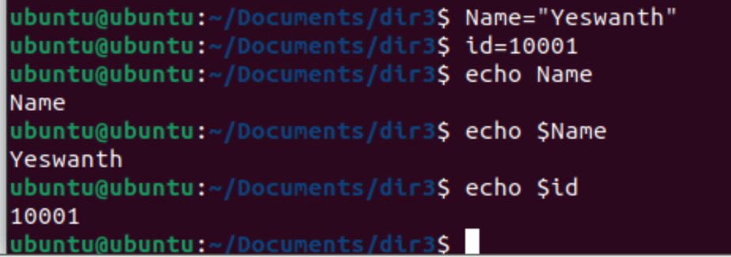

Task 31:

Can you make the above name variable read only..

Ex:

Name = “Prasunamba”

Readonly Name

Name = “Meher” —>what will this display.. Is it saying read only?? Pl check

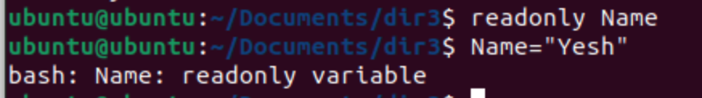

Task 32:

Now will unset or delete the variables

Use the below command and check

Unset Name

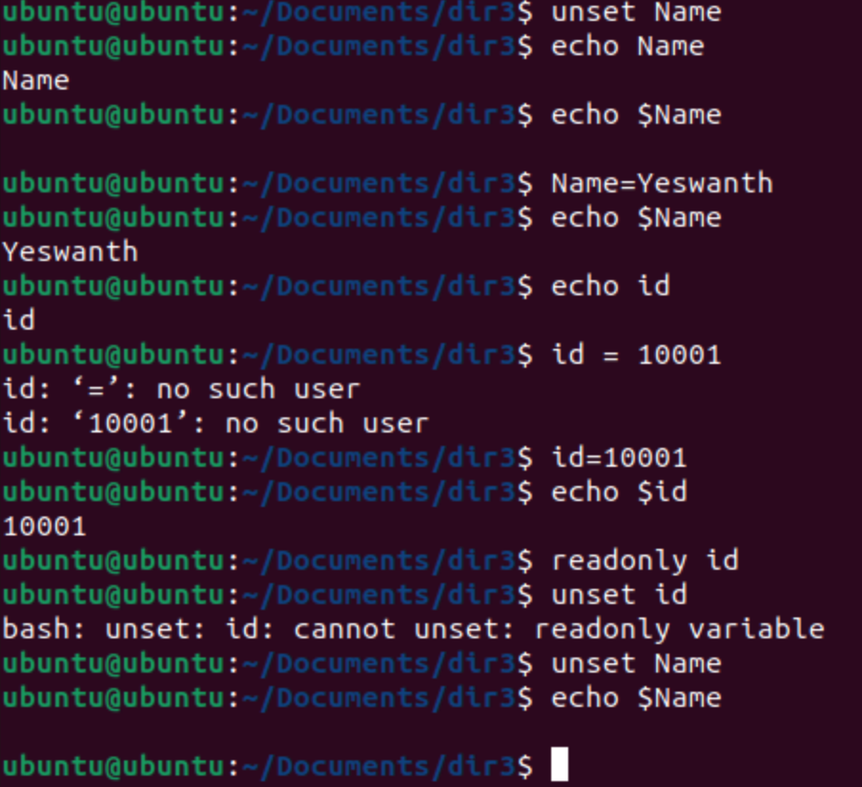

Task 33:

CAn u try to add a list of your friends names in an array and try to printout

Ex:

NAME[0]="Ram"

NAME[1]="Sita"

NAME[2]="Tina"

NAME[3]="Veena"

NAME[4]="Tim"

echo "First Index: ${NAME[0]}"

echo "Second Index: ${NAME[1]}"

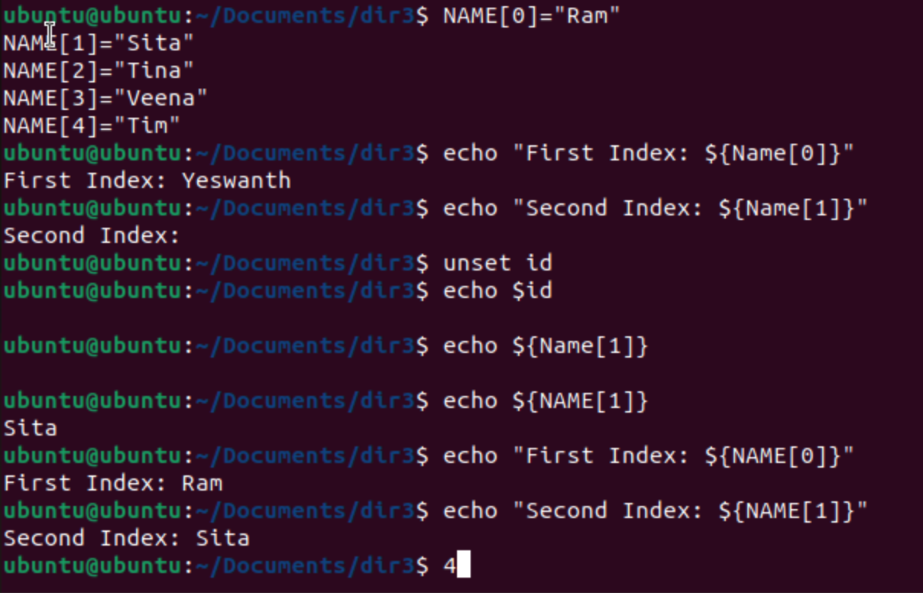

Task 34:

Can you print all the list at once in an array.. Try the below cmds and check

Echo “${array_name[*]}”

Echo “${array_name[@]}”

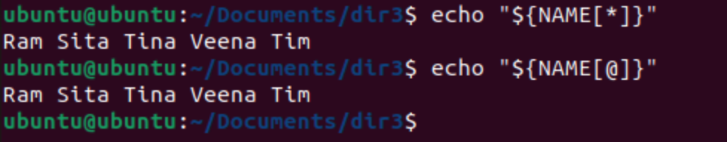

Task 35:

Plz let me know whats the output of the below snippet:

a=0

while [ "$a" -lt 10 ] # this is loop1

do

b="$a"

while [ "$b" -ge 0 ] # this is loop2

do

echo -n "$b "

b=`expr $b - 1`

done

echo

a=`expr $a + 1`

Done

